Step 1: Prerequisites (Windows)
1. Install Java (MANDATORY)
PySpark requires Java.

Install Java 8 or 11 or 17

Here we installing java 17
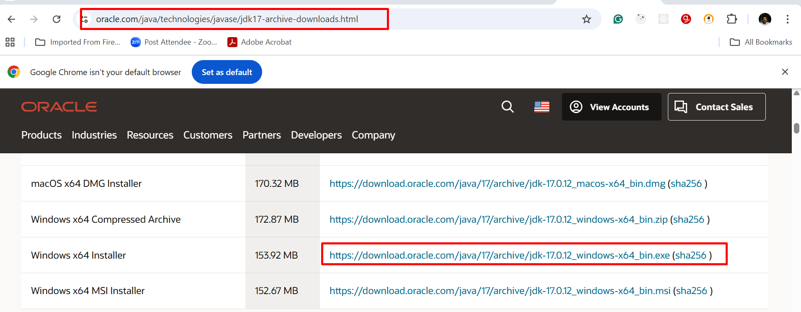

After download install .exe file. It will install java in C drive.

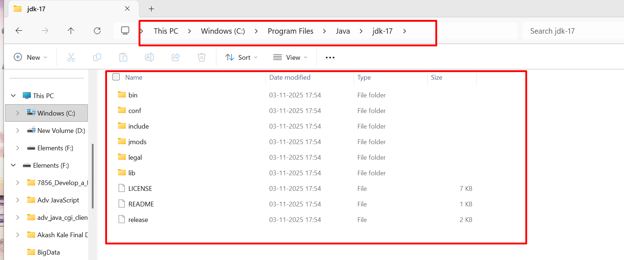

Now we need to set the path for java.
In Window search open environment variable.
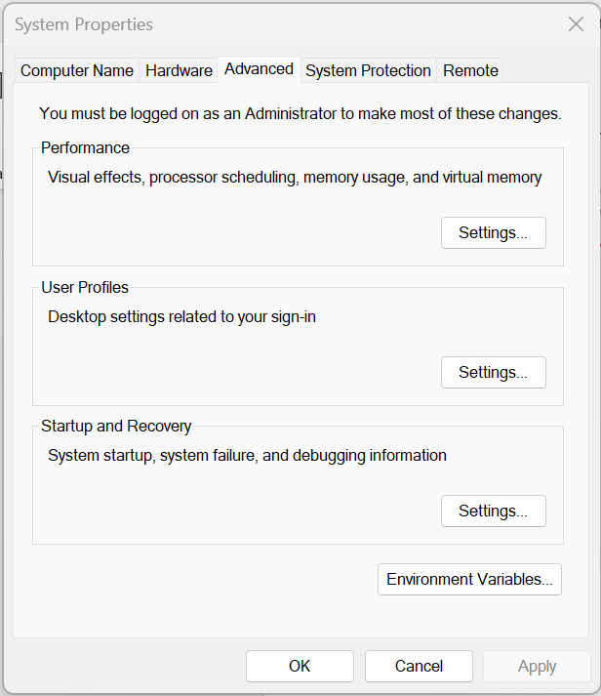

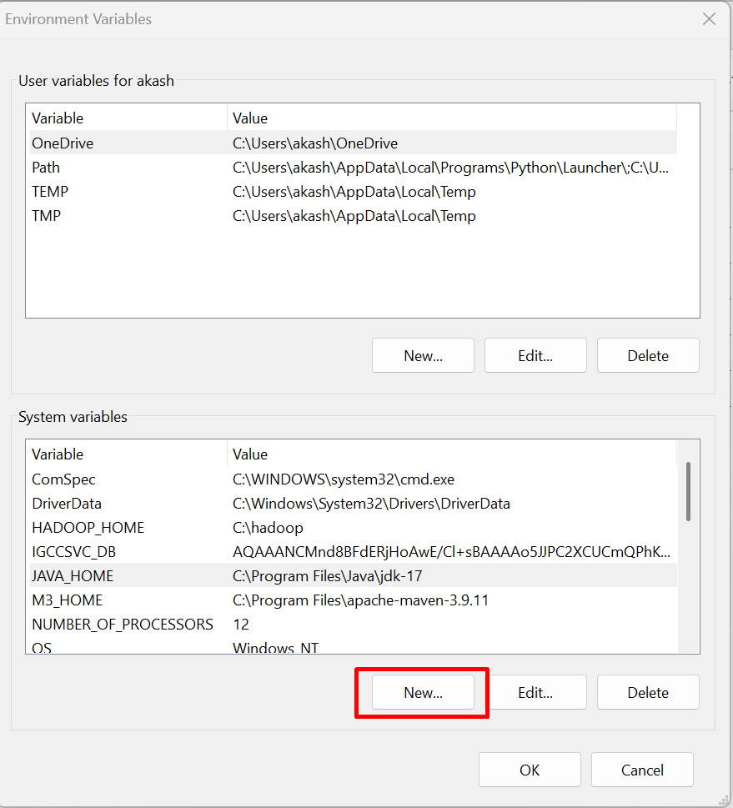

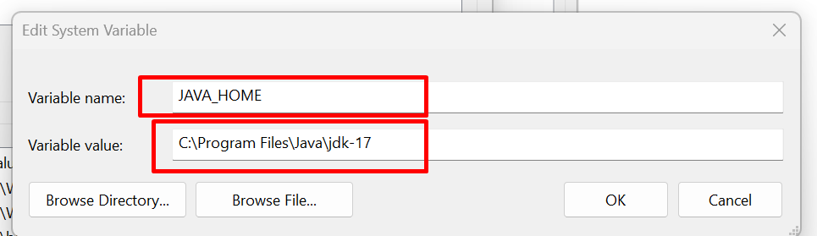

Here variable name is JAVA_HOME and value is home directory of jdk folder.

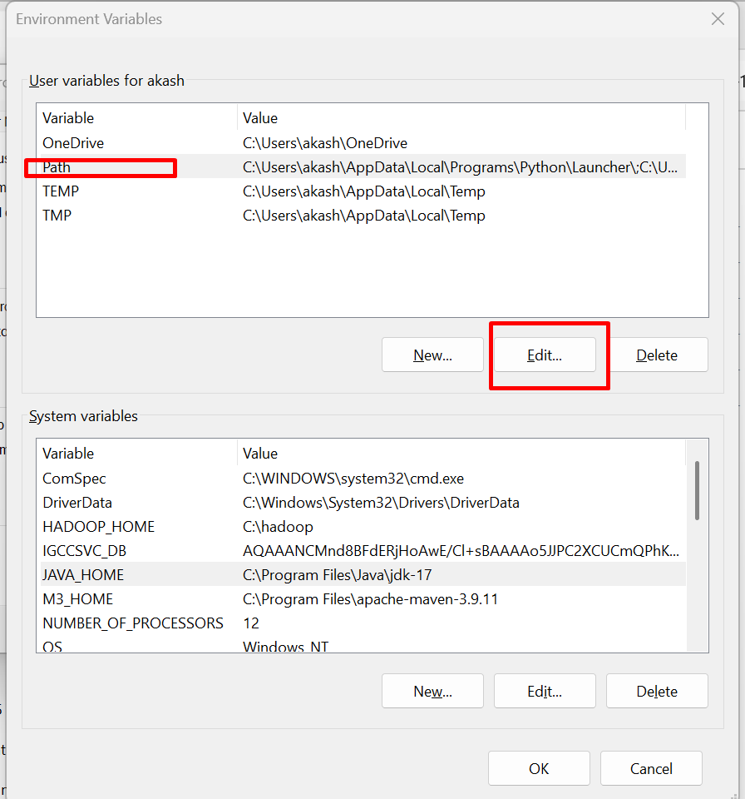

Set the Path for Java home with bin directory
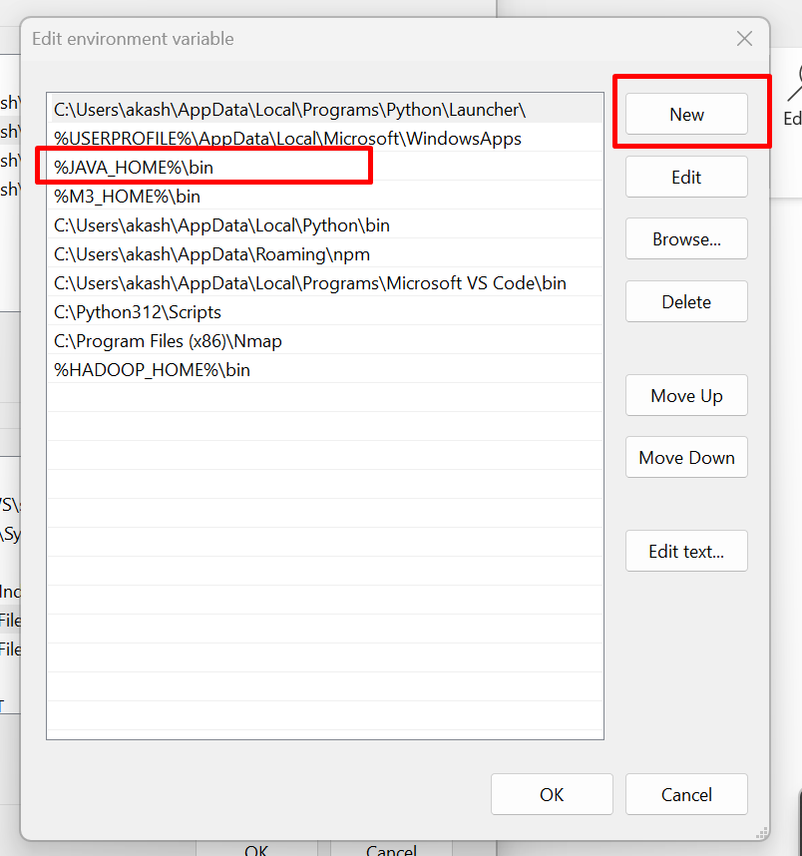

After set verify the Java version
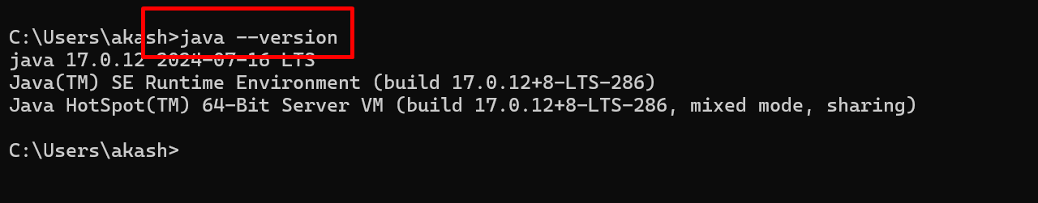

Step 3: Setup Hadoop (Required for Windows)
Spark needs winutils.exe.
Download Hadoop binaries
- Download Hadoop 3.x (prebuilt for Windows)
Download from below URL.
https://github.com/cdarlint/winutils

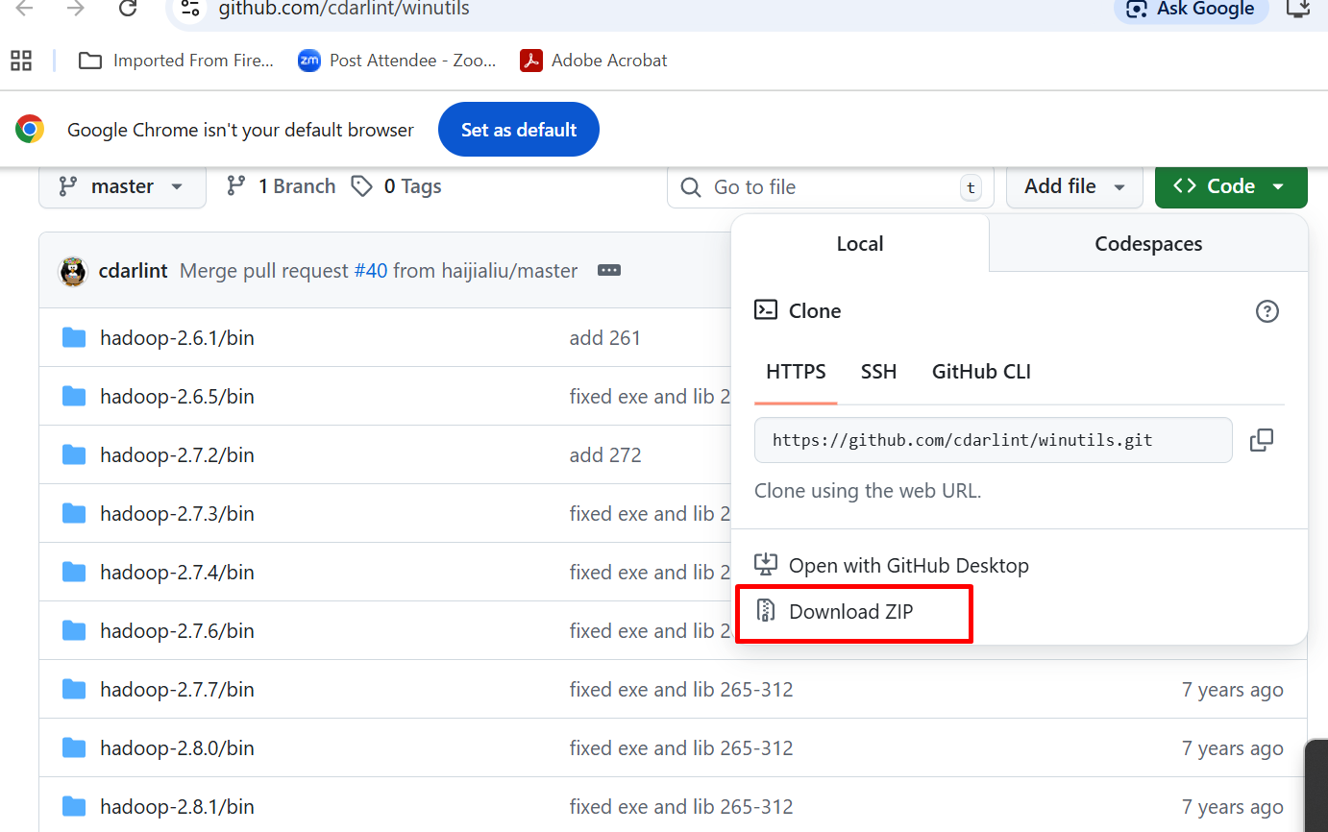

Setup
C:\hadoop\bin\winutils.exe

Create hadoop folder inside a C drive and copy and paste downloaded version 3.x version bin folder inside this folder.
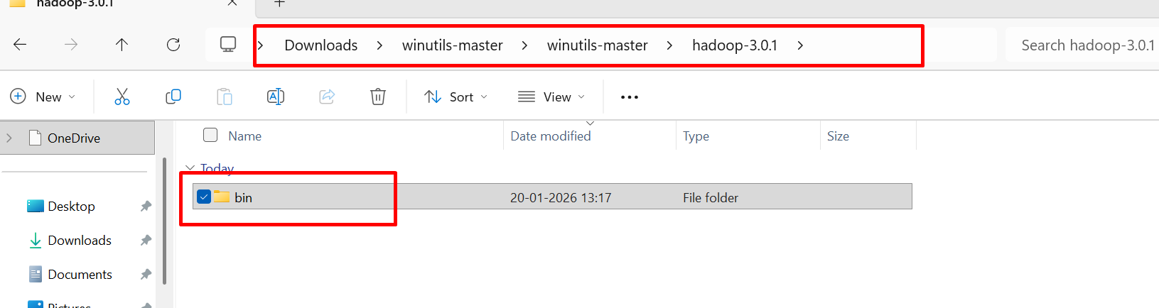

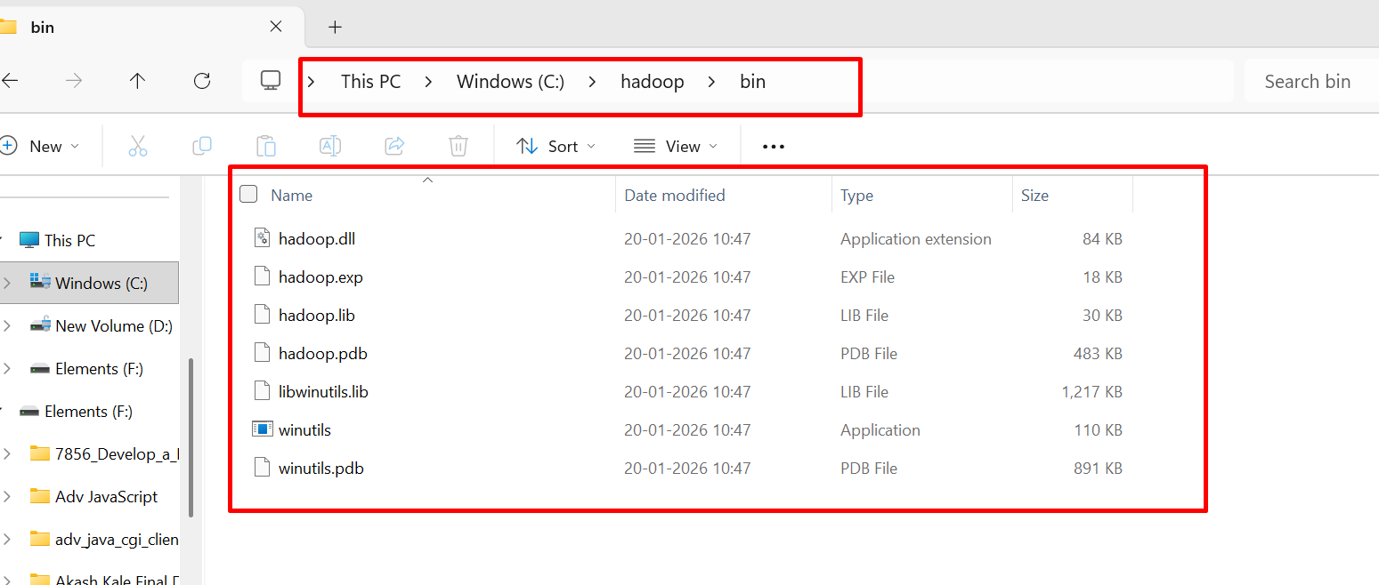

Set the Hadoop path

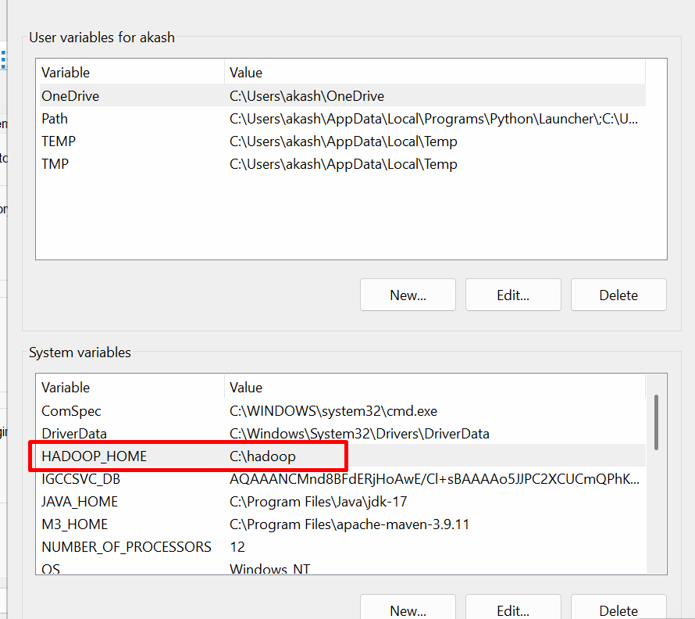

Then you need to set path for Java and Hadoop in user variables.
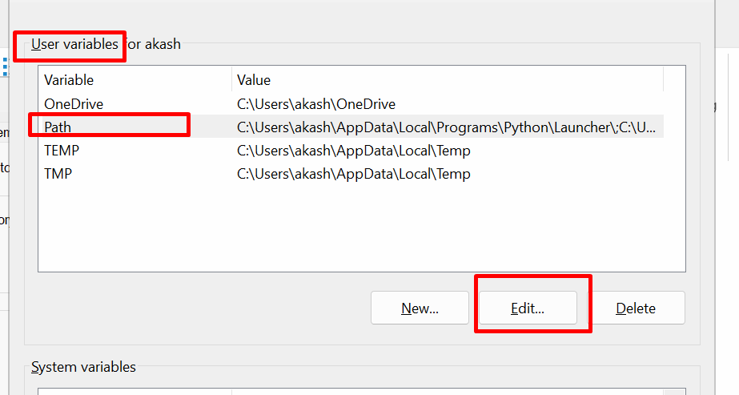
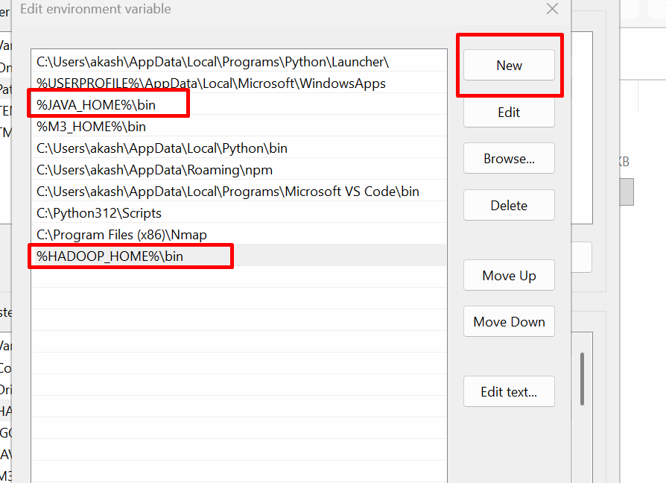

Before that please install the python 3.10
https://www.python.org/downloads/

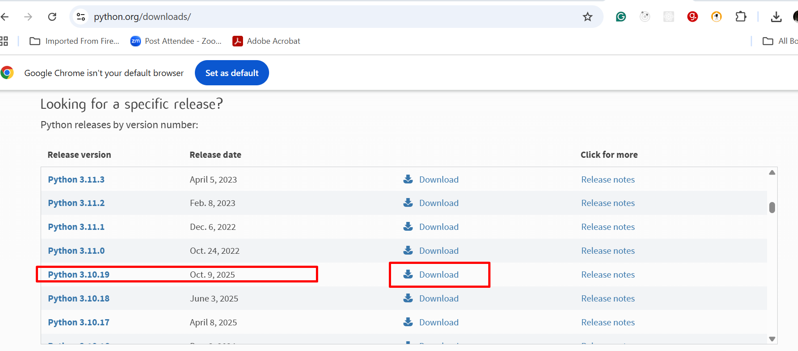

Install download the python 3.10.19 version
Now verify multi version python in your local machine.
Open the command prompt and type below command as

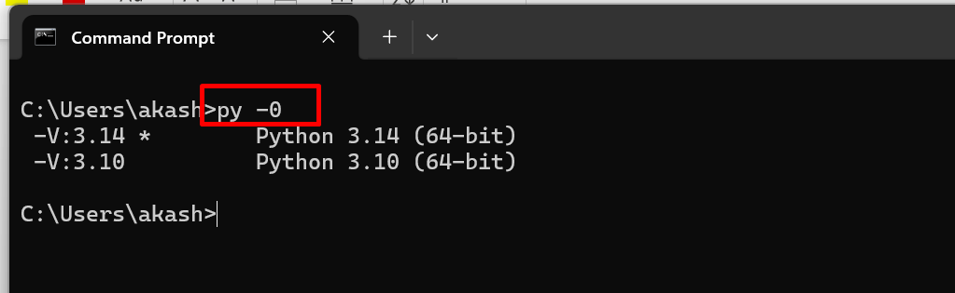

The default version of python is 3.14 and another version is 3.10.
3.10 is stable version of pyspark all modules

Now you need to create python environment

Open the folder and write the below command to create python virtual environment folder
py -3.10 -m venv spark-evn
activate virtual environment folder

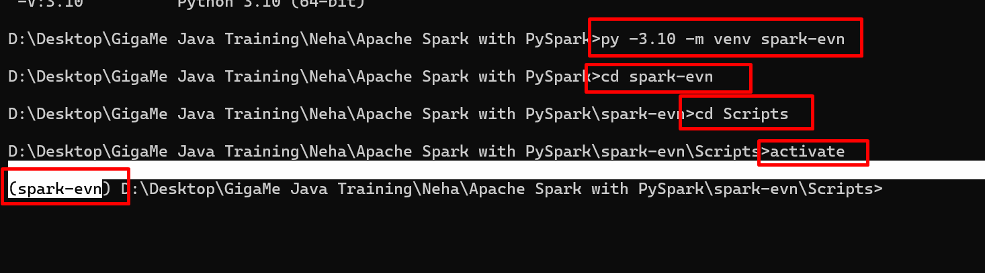

Now we will install pyspark module

python -m pip install pyspark==3.5.1

Step 4: Install Netcat (Streaming Source)
We need a live data source.
Option A: Using ncat (recommended)
Download:

https://nmap.org/ncat/

After install, verify:
ncat --version

NCAT (from Nmap) is a command-line networking tool used for testing, debugging, automation, and learning TCP/UDP networking—especially useful on Windows.

